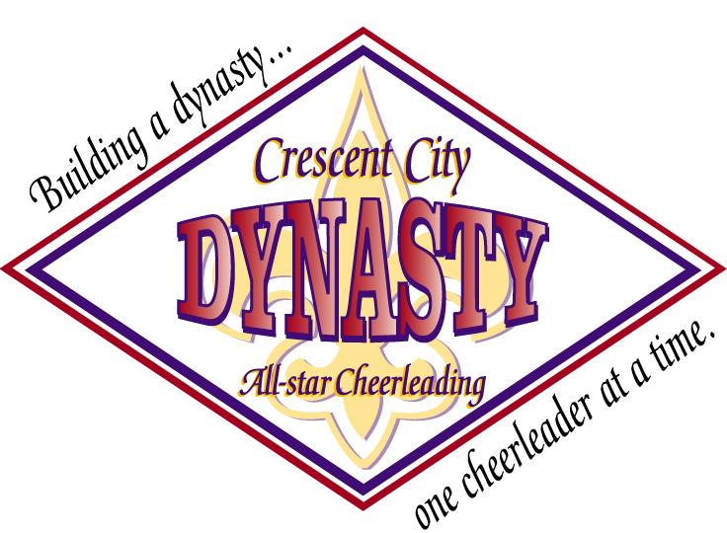
Crescent City All-Star Cheerleading, L.L.C.
Phone: (504) 305 - 1199 E-Mail: coachfran@crescentcitycheer.com
www.crescentcitycheer.com
Tumbling Class Registration Form

Cheerleader’s Name:______________________________________________________________________________________

Parent’s name:___________________________________________________________________________________________
Address:________________________________________________________________________________________________
Street city, state & zip code

Parent’s e-mail address:______________________________________ Home Phone:________________________________

School:___________________________________________________ Date of Birth:________________________________

Cheerleading’s Age as of May 2007: _________

Cheerleading Experience (if any):___________________________________________________________________________

Dance Experience (if any):_________________________________________________________________________________

Most Difficult tumble skill (if any):_____________________________________________________________________________________________

Injuries – Please list any and all health conditions (i.e. Asthma, allergies, etc.) or previous injuries that would affect

performance. List any breaks, fractures, sprains, muscle pulls etc.___________________________________________________________

__________________________________________________________________________________________________________________________________

Parent acknowledges that the Crescent City All-Star Cheerleading Program (CCAC) involves risk to your child. Parent further acknowledges and understands that due to the nature of this activity, which includes inversion and rotation of the body, there is a possibility that your child may sustain physical illness or injury (minimal, serious, or catastrophic), in connection with your child’s participation, including but not limited to try outs. Parent further acknowledges and understands that Parent and child are assuming the risk of such physical illness or injury of your child arising out of, connected with, related to, pertaining to, or resulting from, either directly or indirectly, your child’s participation in the CCAC Program, and Parent and child further release CCAC and all CCAC’s coaches, agents, representatives, directors, members, officers, employees, insurers, servants, subcontractors, subsidiaries, affiliated companies or joint ventures or otherwise, whether or not existing prior to the date of this agreement, (collectively, “Released Entities”), from any claims for damage (including, but not limited to claims, demands, or actions for bodily injury, illness, disease, death, loss of society, maintenance, wages, or property) that your child may sustain arising out of, in connection with, or resulting from participation in the CCAC Program including tumbling classes whether occasioned, brought about, or caused in whole or in part by the negligence, fault, strict liability or intentional conduct of Released Entities, or by any defective condition of any equipment, property or buildings owned, operated, rented, leased, or controlled by Released Entities, regardless of whether such negligence, fault, strict liability or intentional conduct or defective condition be gross, sole or contributory, active or passive, primary or secondary.

PARENT/GUARDIAN’S SIGNATURE:_____________________________________________________DATE___________________________

